#### **Android Developer Work Challenge for Prepr**

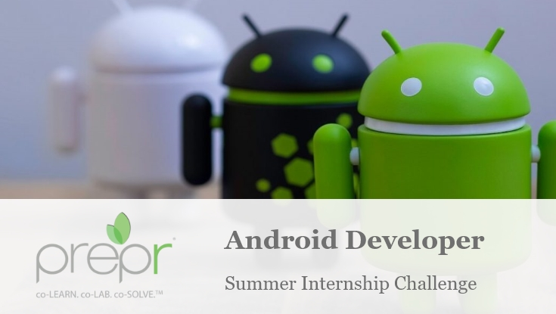

**Published by : Saeideh Taleshi**

**Saeideh.taleshi@gmail.com**

## Mobile Project Description Proposals: “The Hydraulica APP”

## 1) “The Hydraulica APP”

The “*Hydraulica APP*” is the Android Mobile Application Project designed for YWCA and customized for Prepr Challenge.

## Android Files

Show the following files: ***R.java***, ***app-debug.apk,***

***build.gradle (MODULE), build.gradle (PROJECT)***.

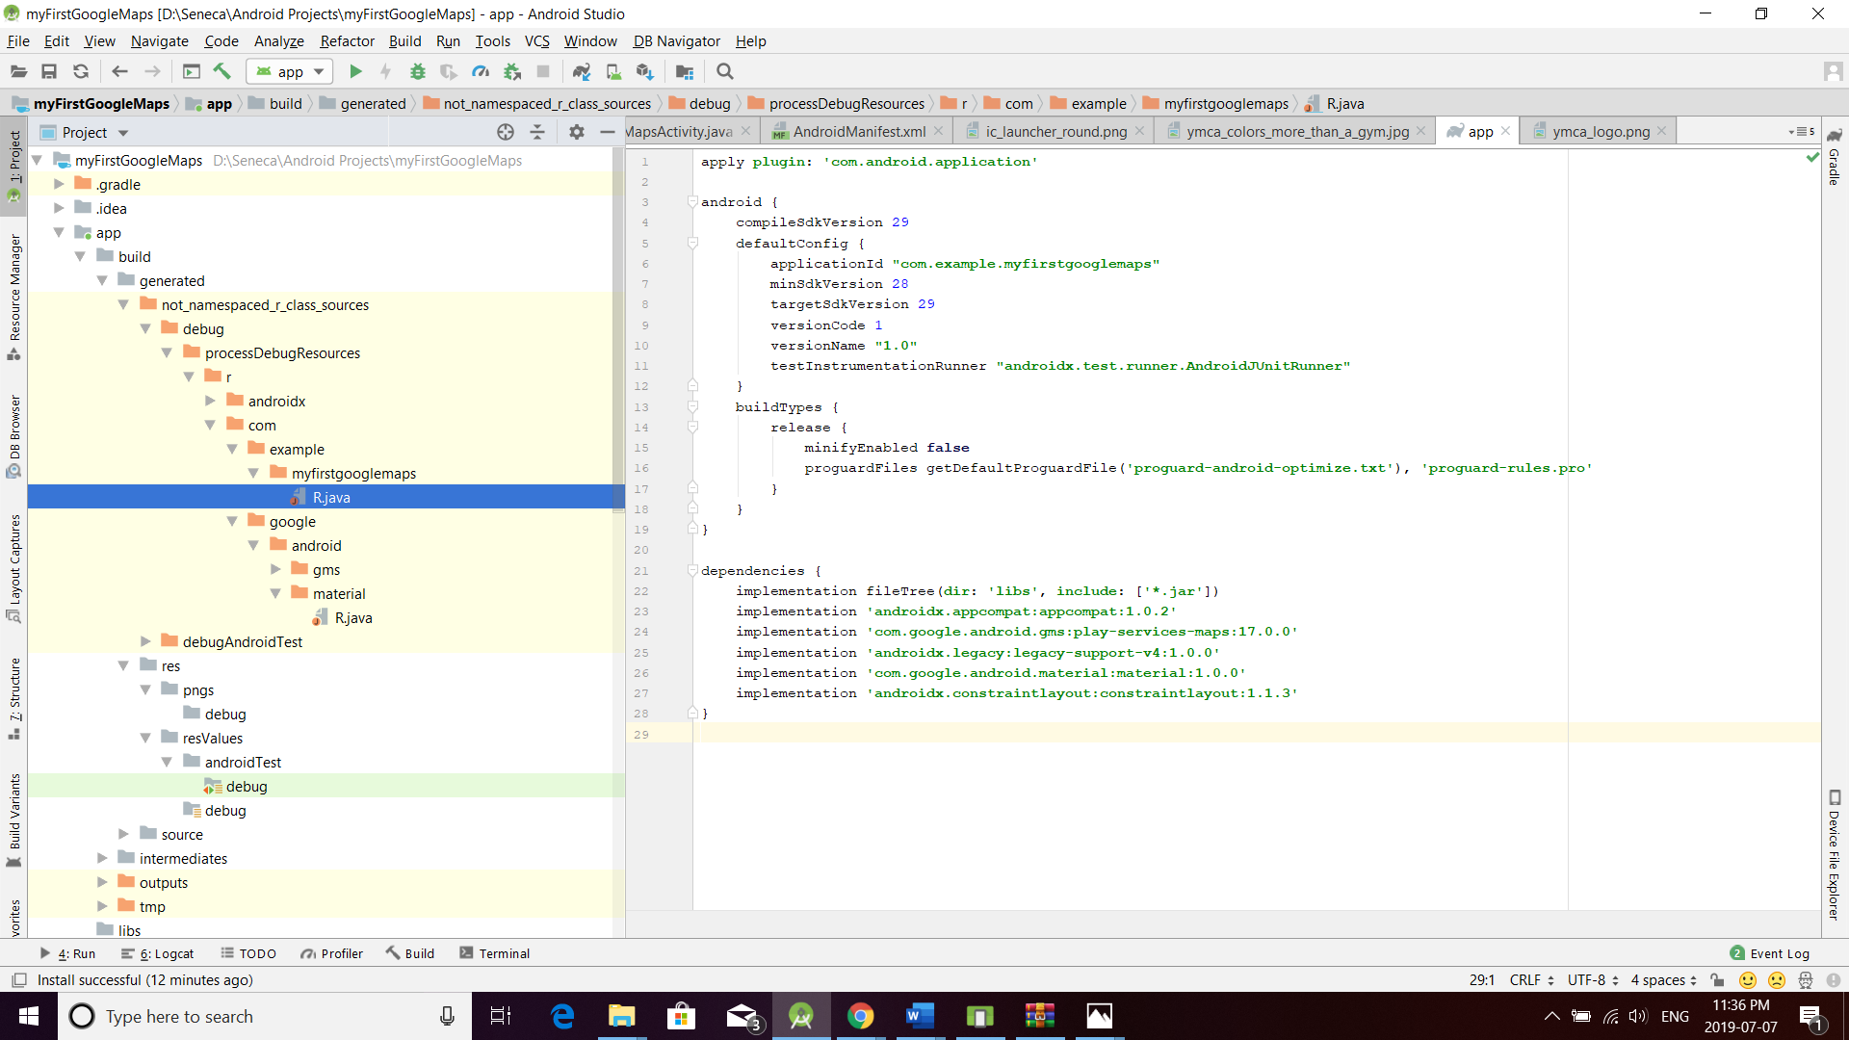

***app-debug.apk,***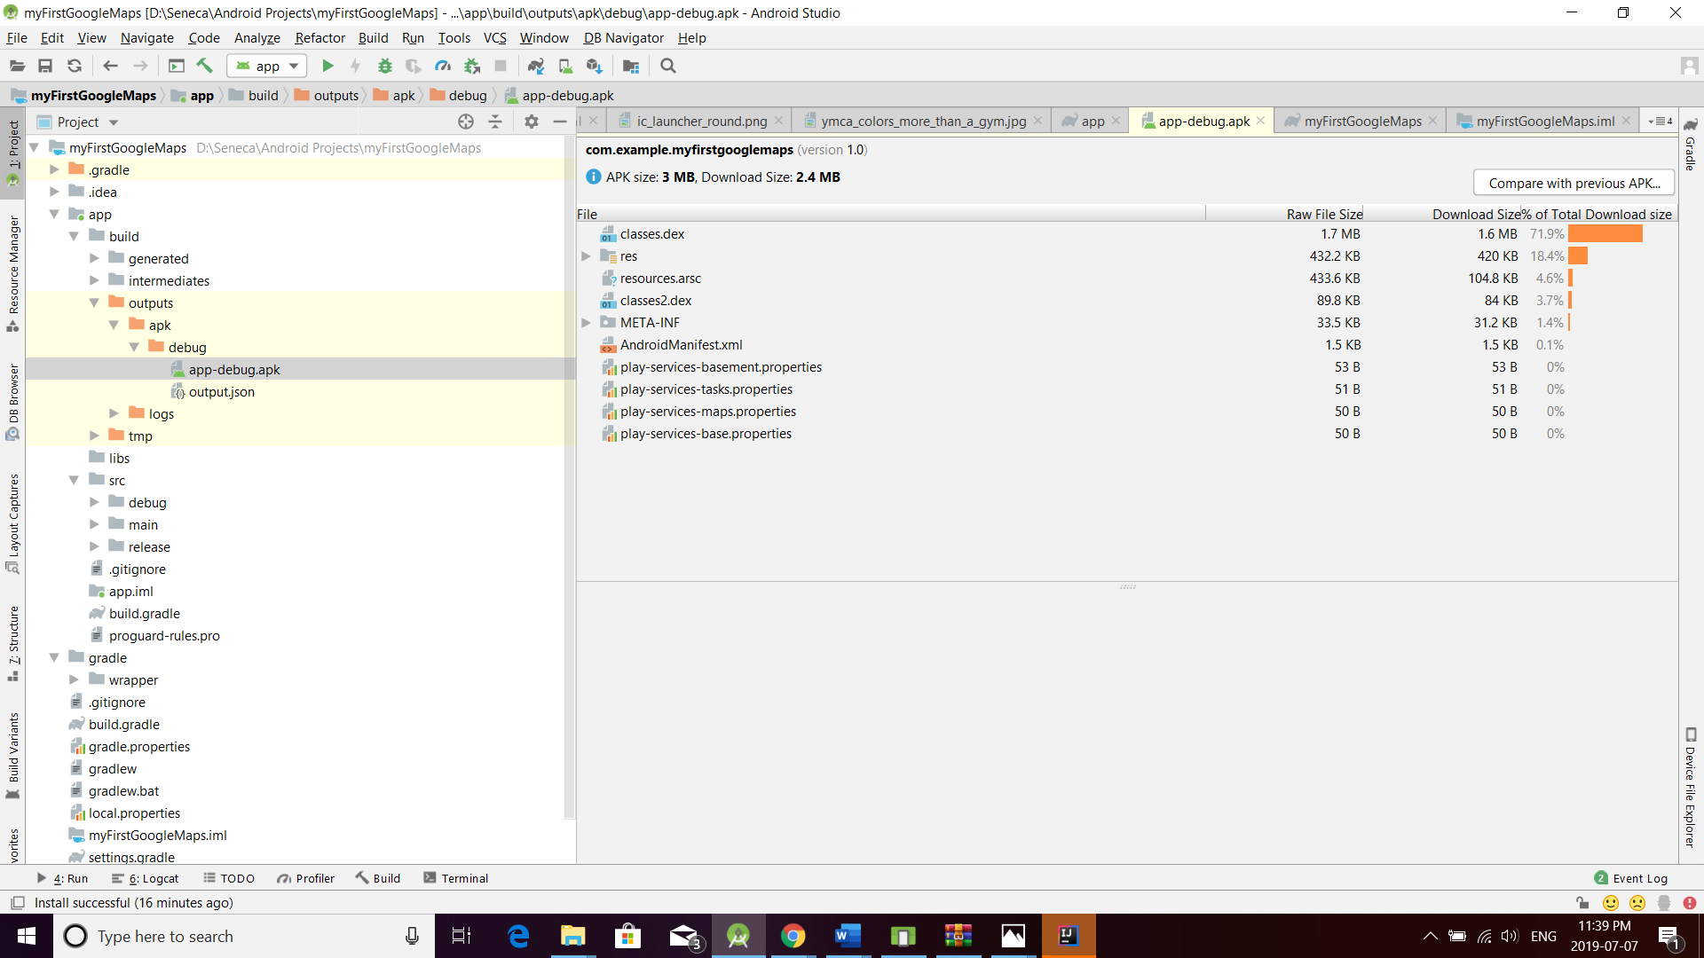

Build.gradle

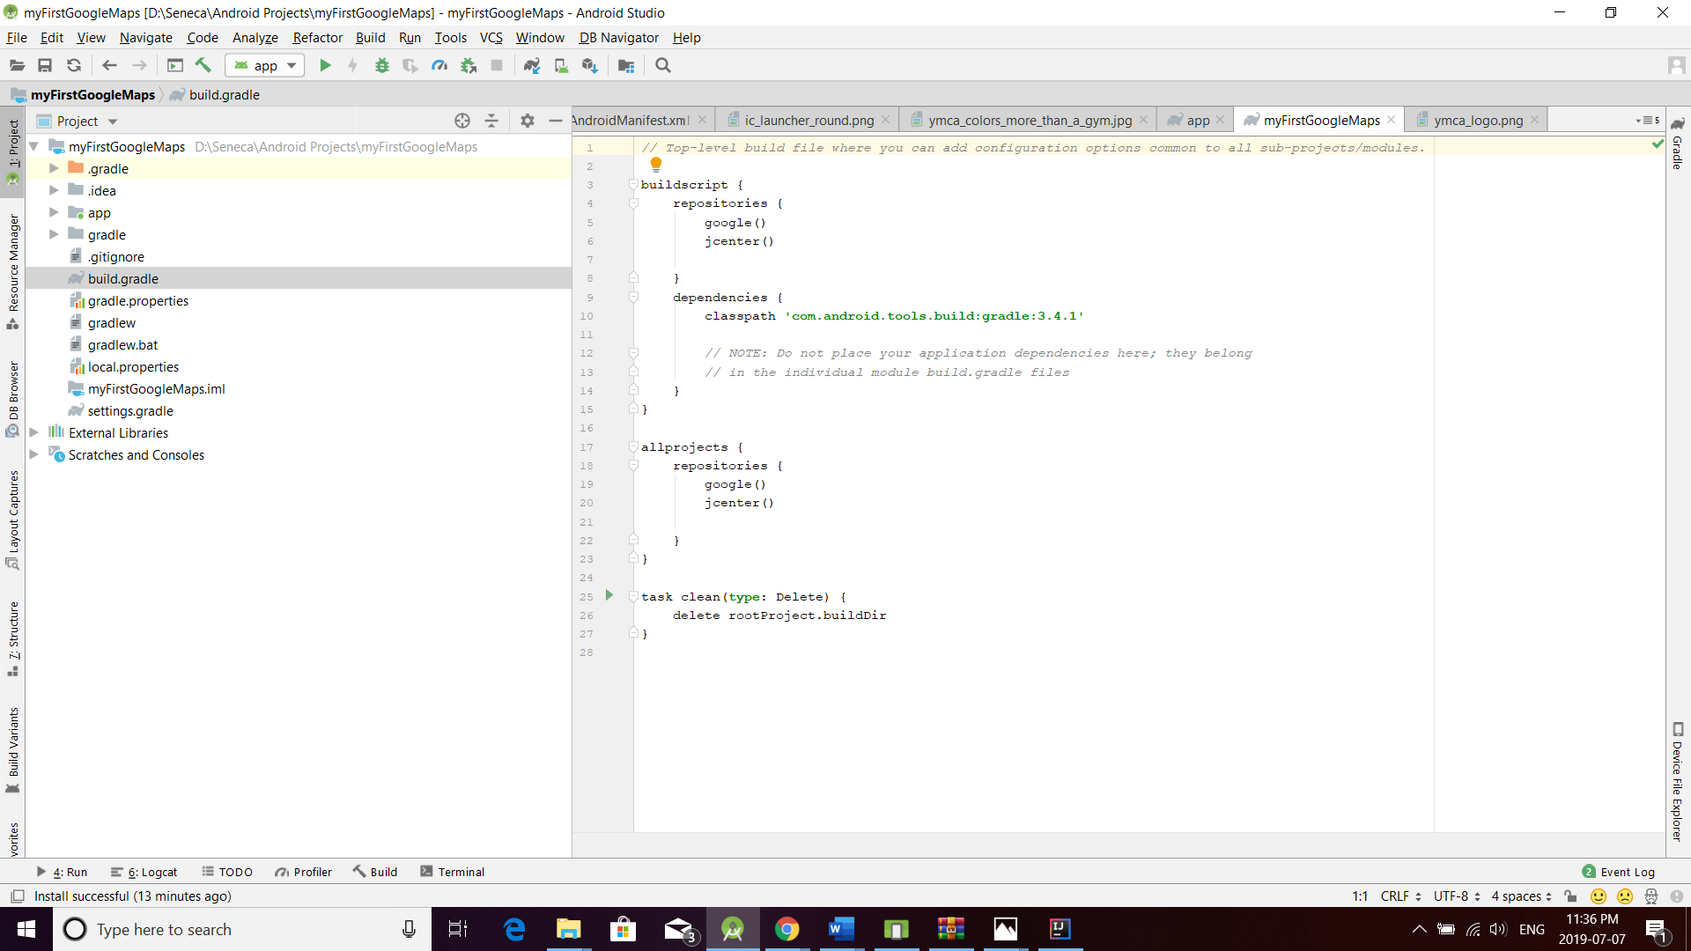

Build.gradle

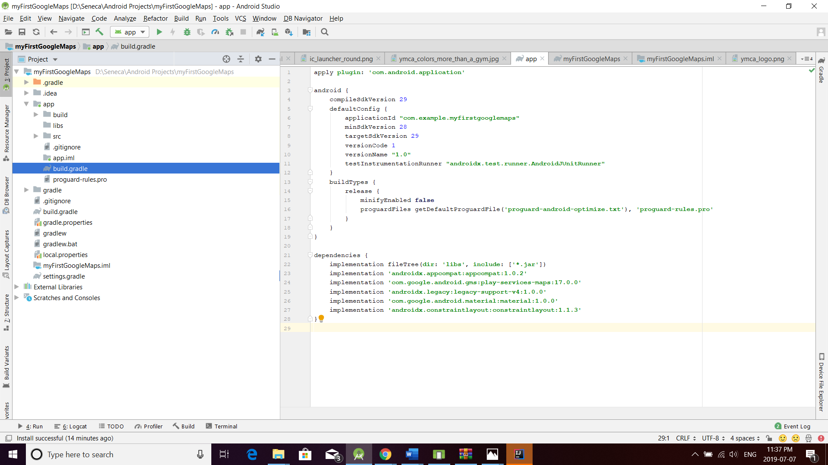

## Android Gradle Console

In this pictutre you can see ***BUILD SUCCESSFULL*** from the *Gradle Console*.

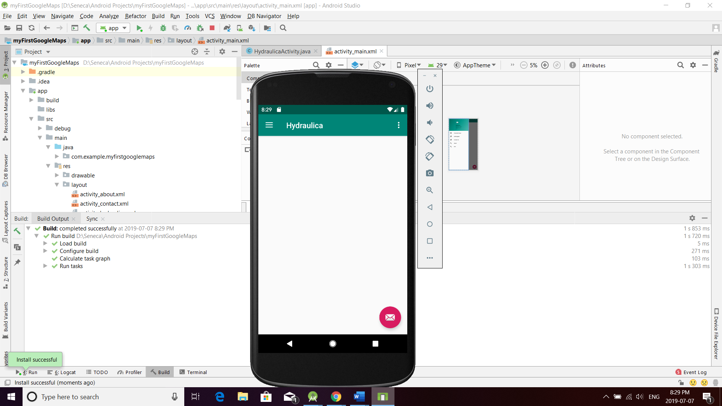

## Android Repositories

The result of browsing to the following online REPOSITORIES used by Gradle:

[***http://jcenter.bintray.com***](http://jcenter.bintray.com/)

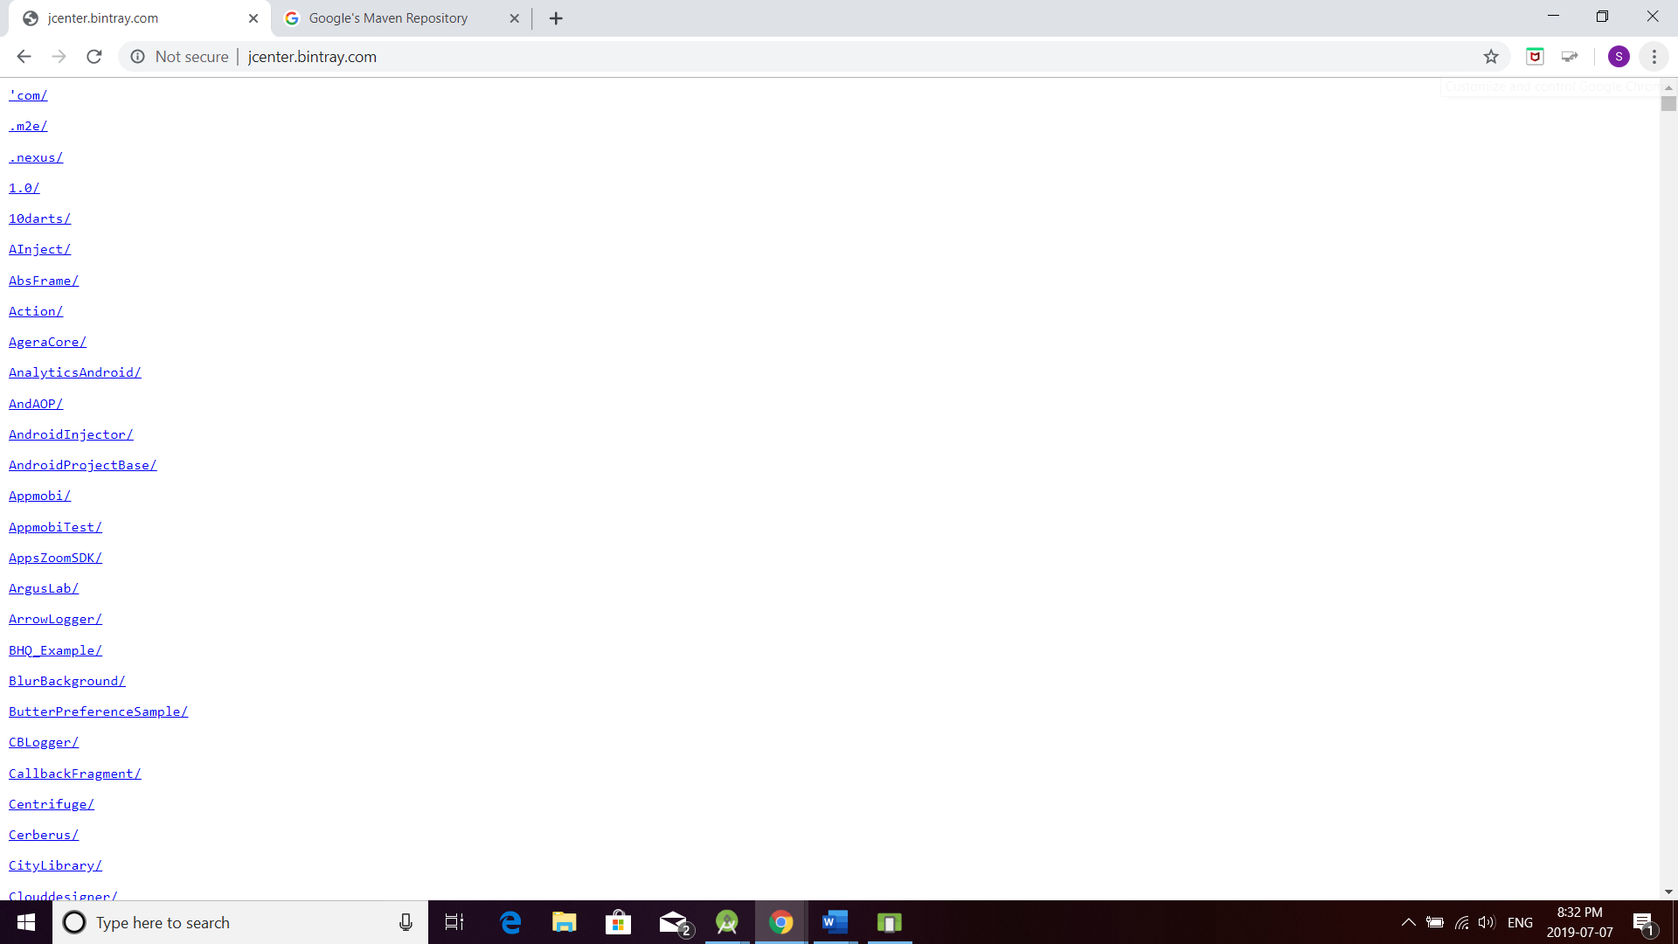

[***http://maven.google.com***](http://maven.google.com/)

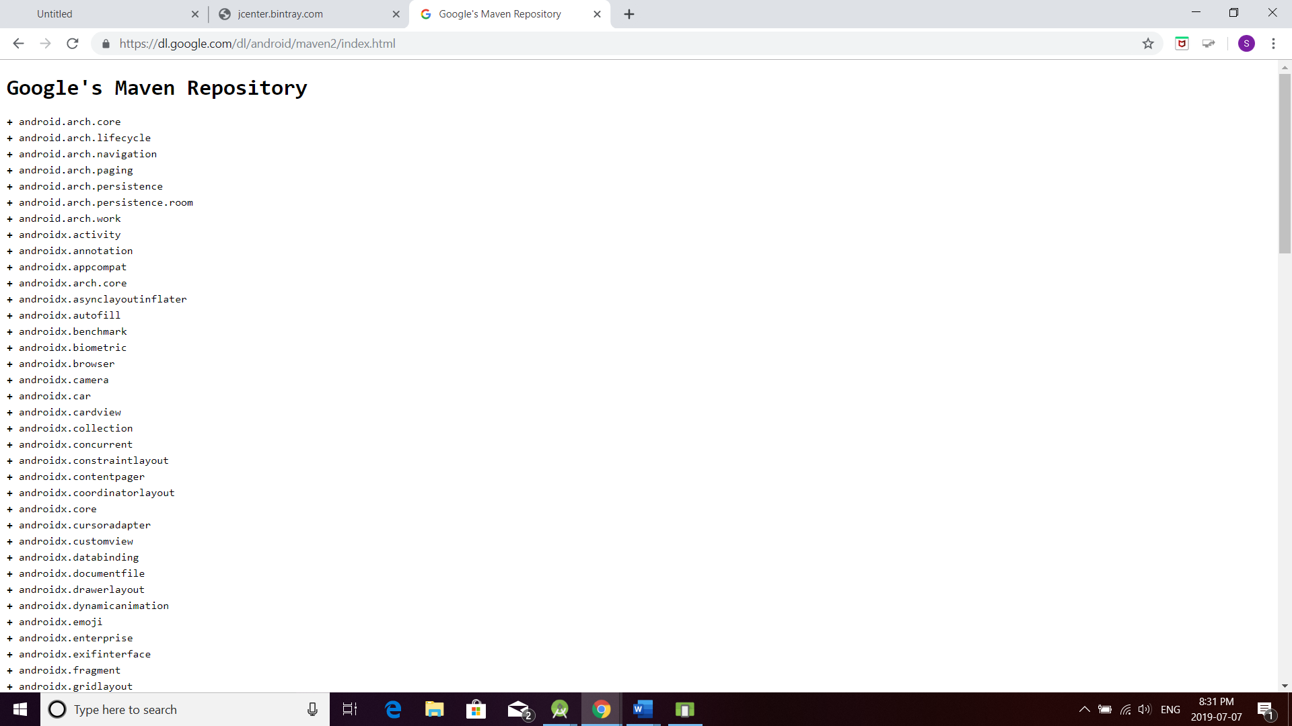

## GooglePlay Store

## The GooglePlay store where APP in RELEASE mode or published :

[***http://play.google.com***](http://jcenter.bintray.com/)

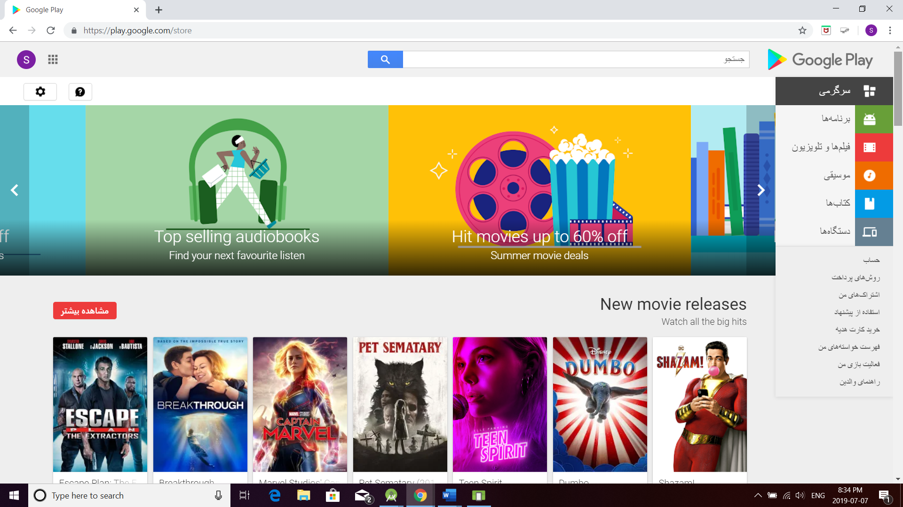

## Android Project Testing

I removed ALL un-needed “***AndroidTest***”, “***test***”, “***JUnit***”, “***Instrumentation Test***” folders as well as un-needed Gradle dependencies.

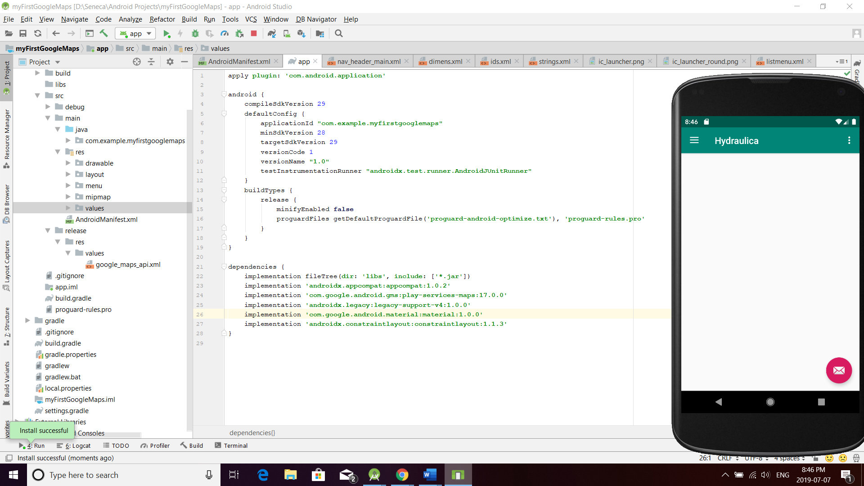

## Android Resource or Configuration Qualifiers

I removed ALL un-needed Resource Qualifiers and ONLY show NEEDED root folders under the RES project tree.

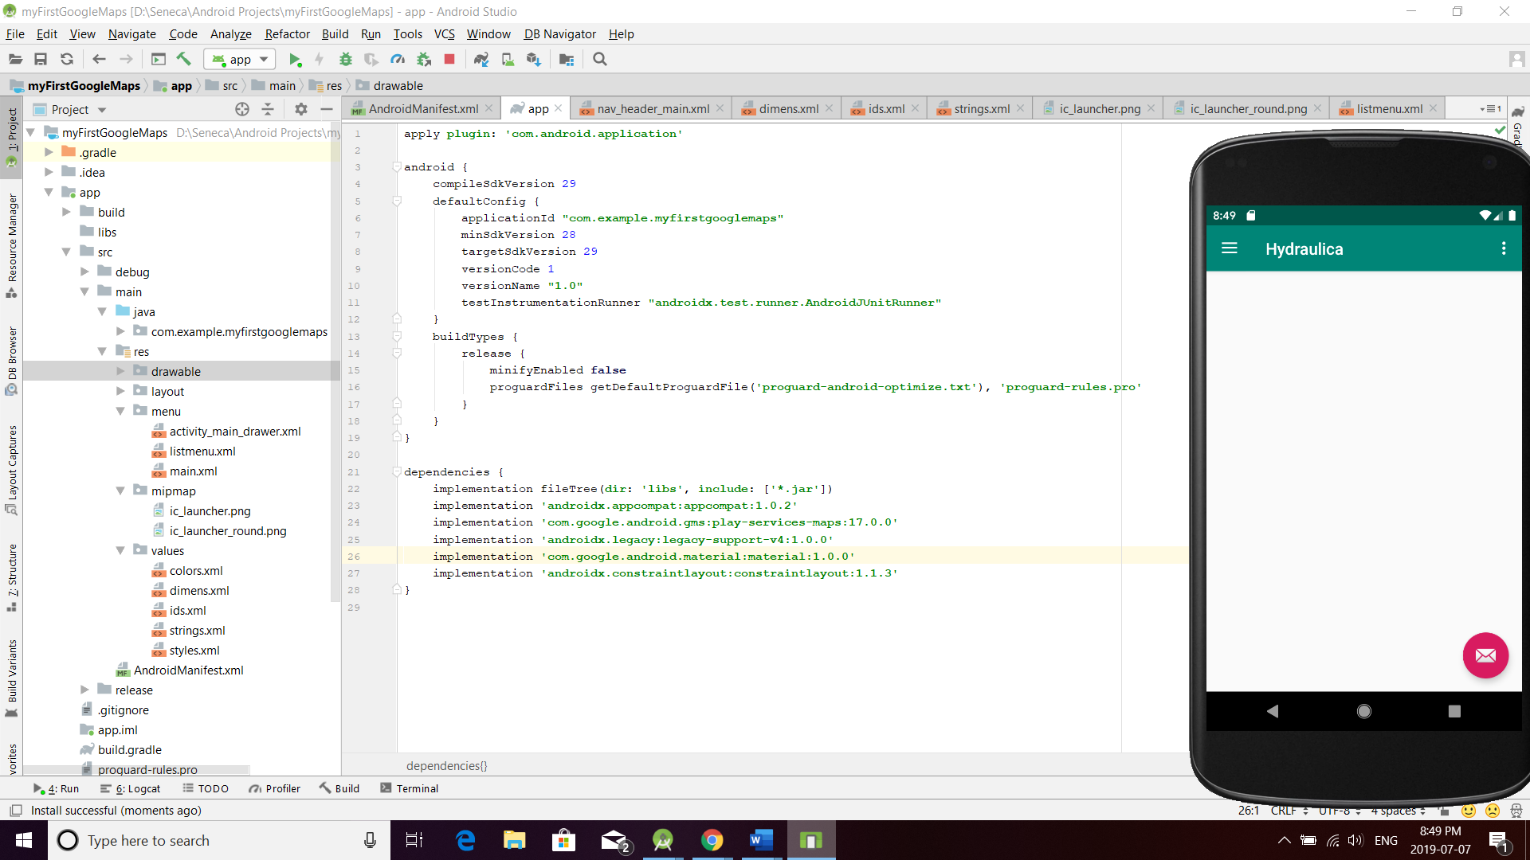

********************

***************************

I created 3 different values folders to support different horizontal margins adjustments between Smartphone devices, 7-inch (***w720dp***) as well as 10-inch (***w1024dp***) tablets.

I Includes support for 2 languages from different countries or regions :

***en-rCA, fr-rCA***and***fr-rFR***

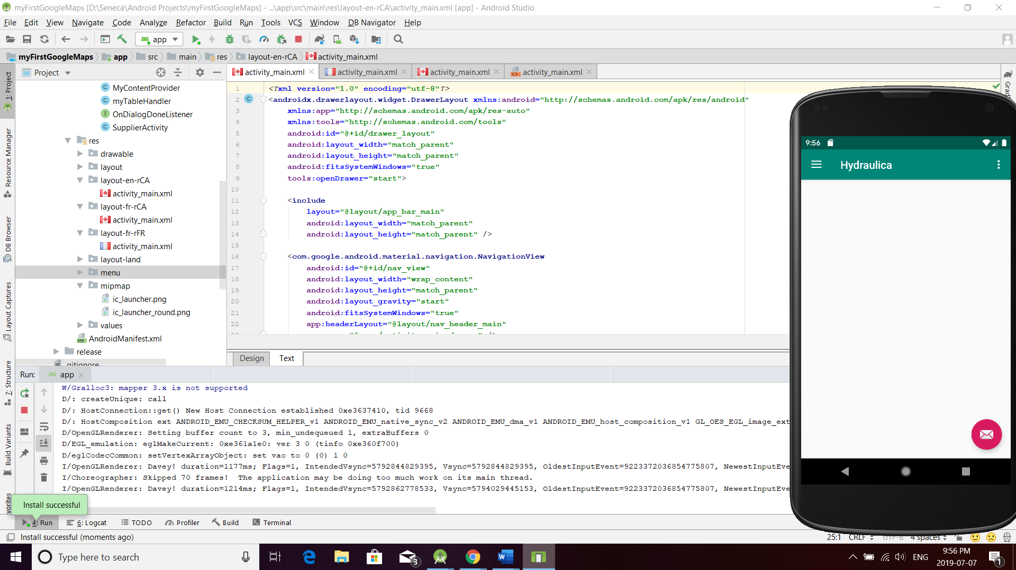

## Debugging/Profiling Strategy

I demonstrated a debugging strategy using LogCat. One of those tags include a Debug Filter : ***ActivityManager*** (from Android Framework).

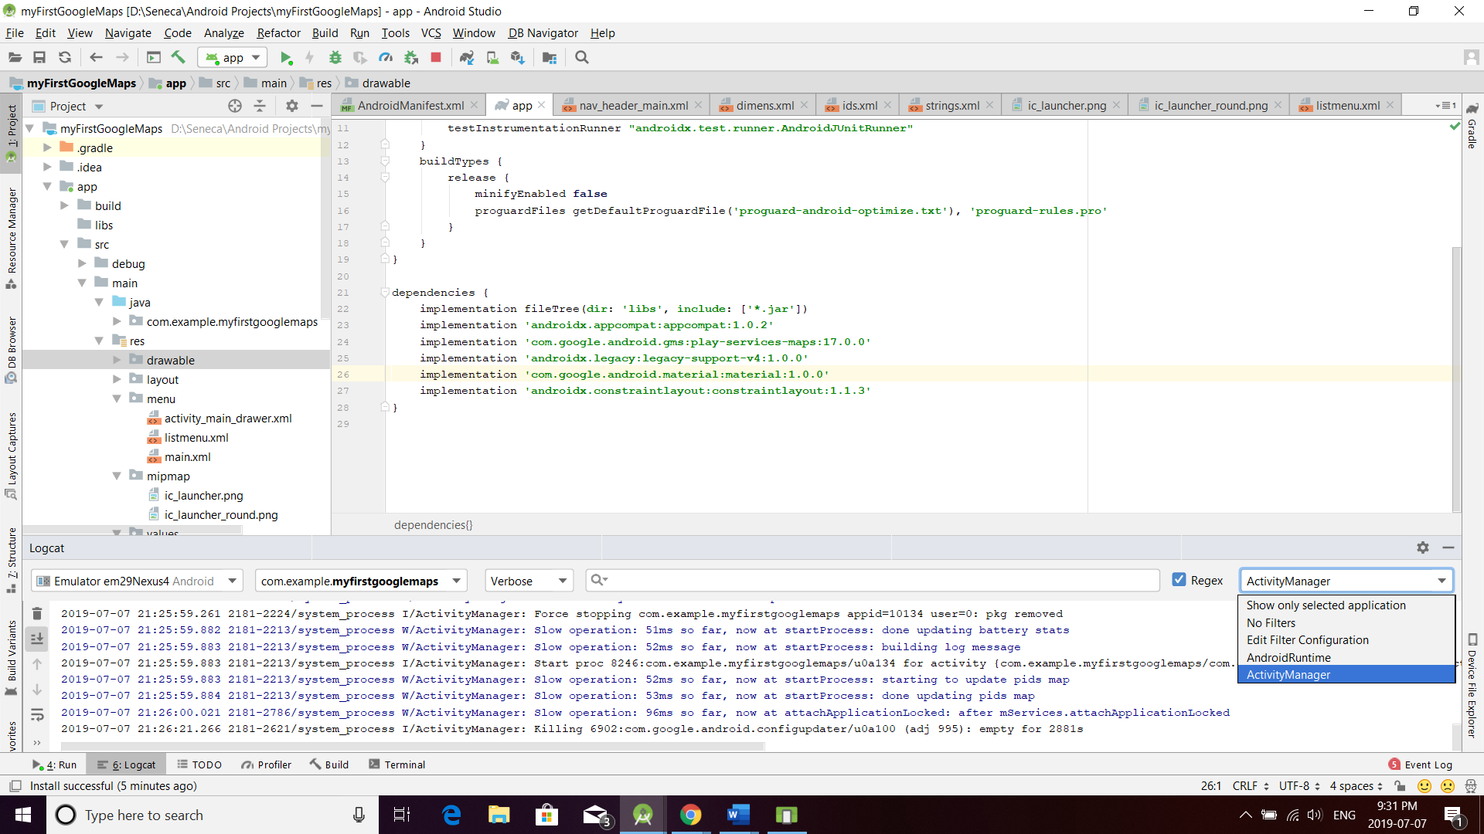

From *Android Studio – Terminal*, interaction of the emulator with the *adb (Android Debug Bridge)* such as: ***adb devices:***

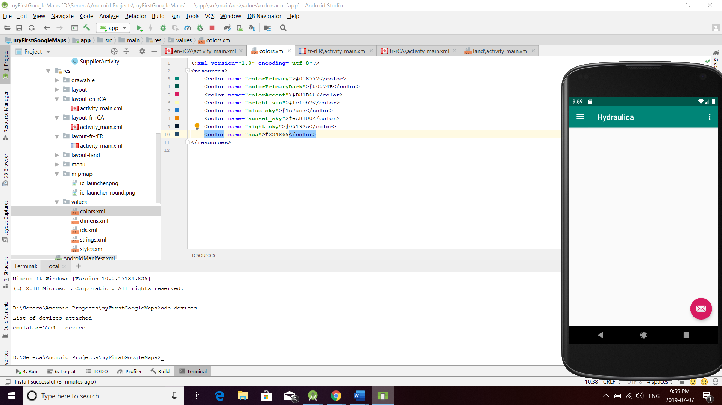

***adb shell***

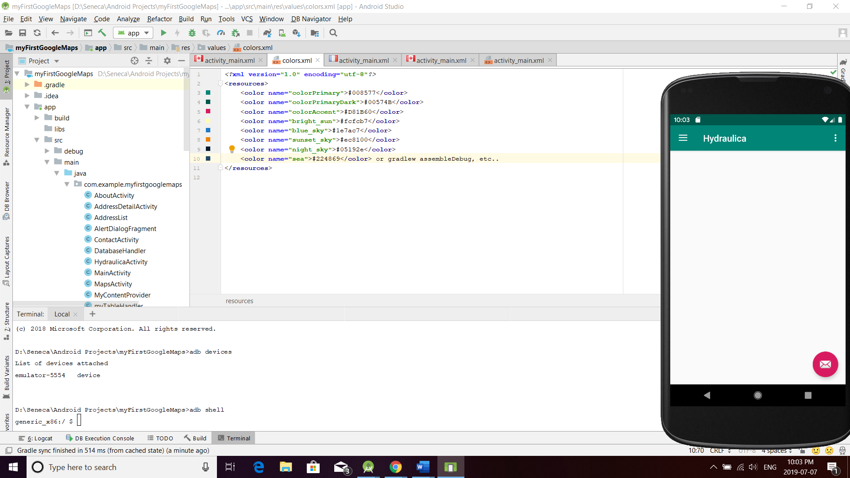

Once the “Hydraulica AP” is deployed to the emulator and running, show the “***Android Profiler***”.

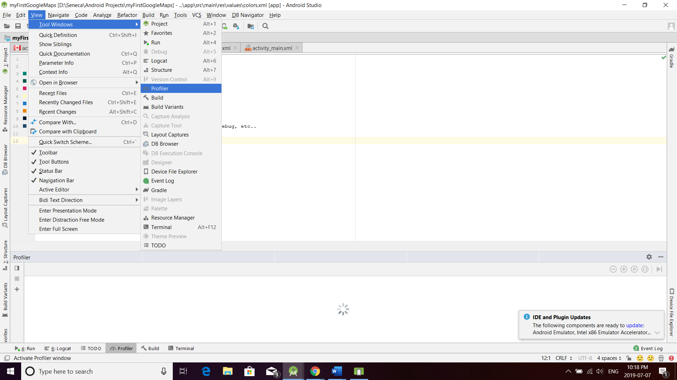

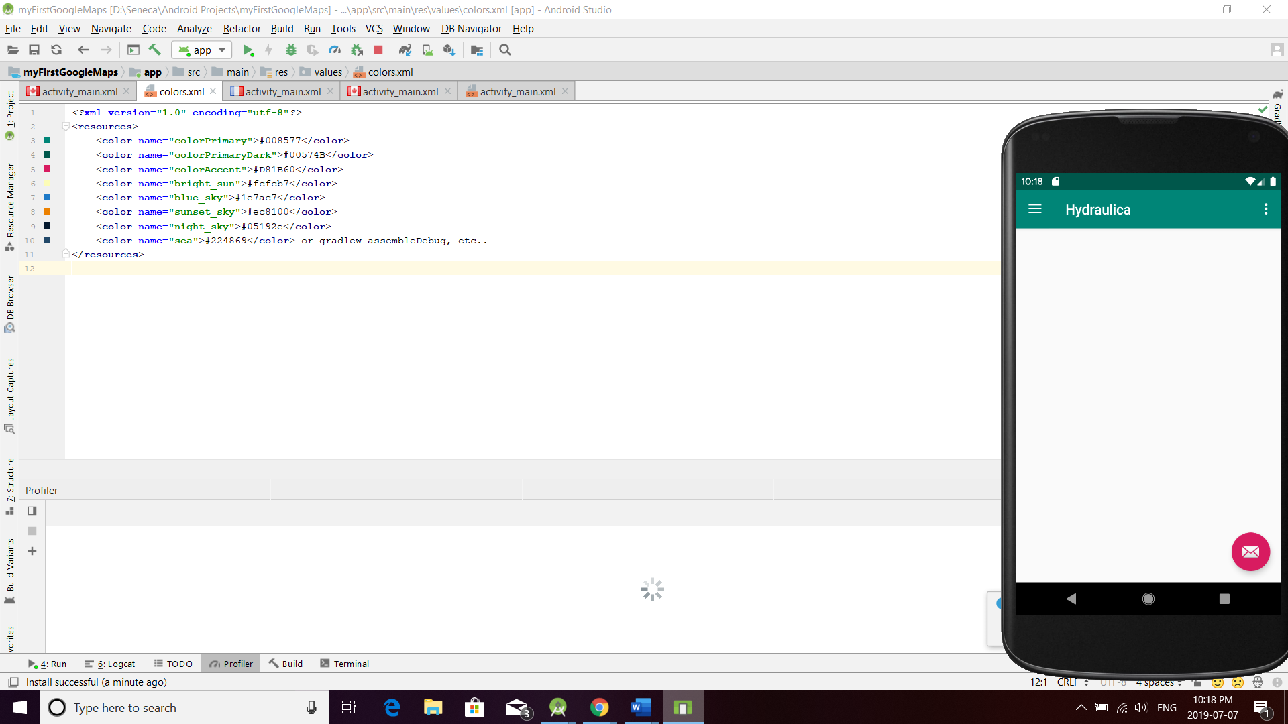

The other filter is StudentName:

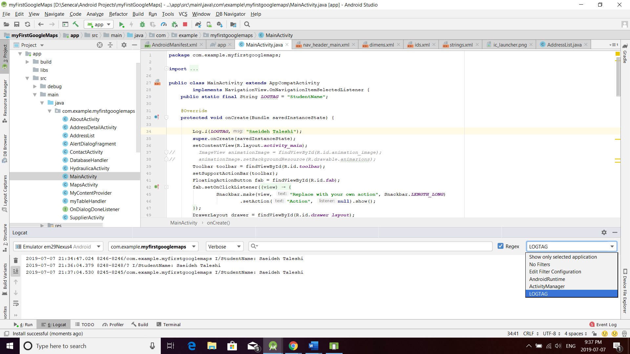

Screen shot of the YWCA Droid icon deployed to the emulator:

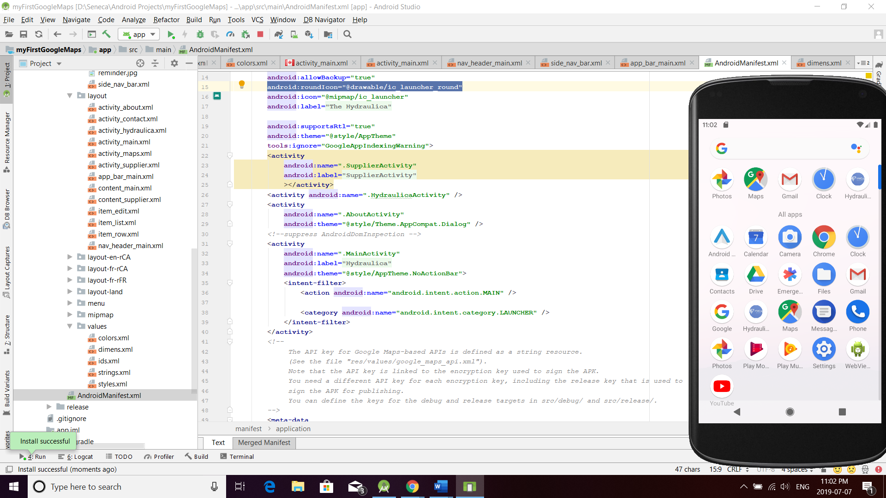

Usage of “Navigation Drawer Activity”.

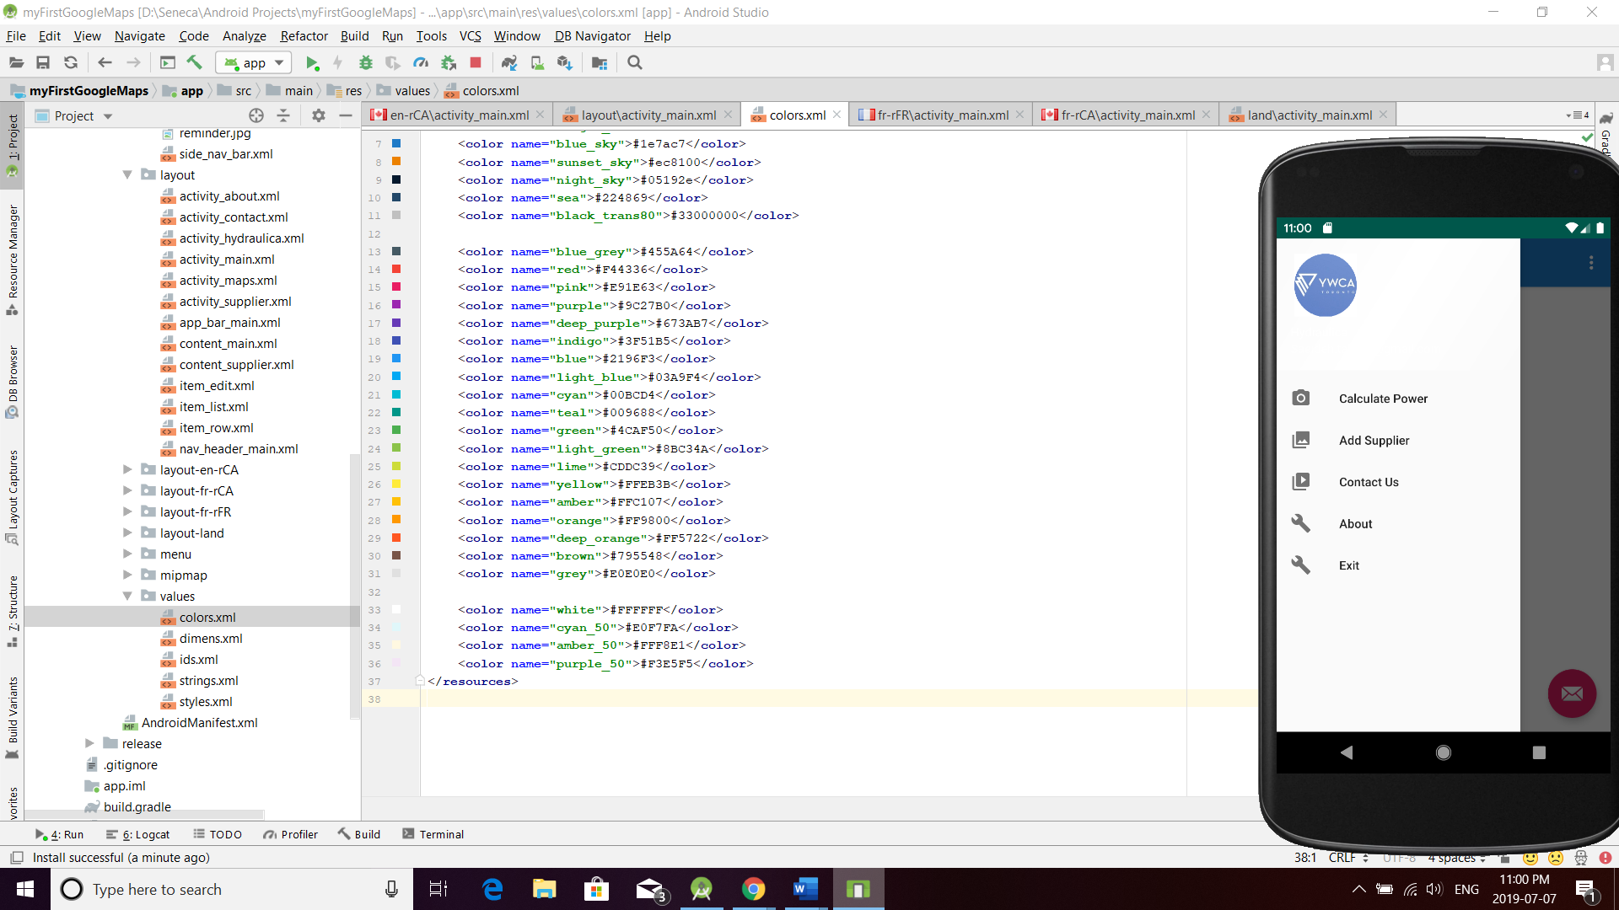

I defined the following LHS (Left-hand Side) Menu options:

“Calculate Power”, “Add Supplier”, “Contact Us”, “About”, “Exit”

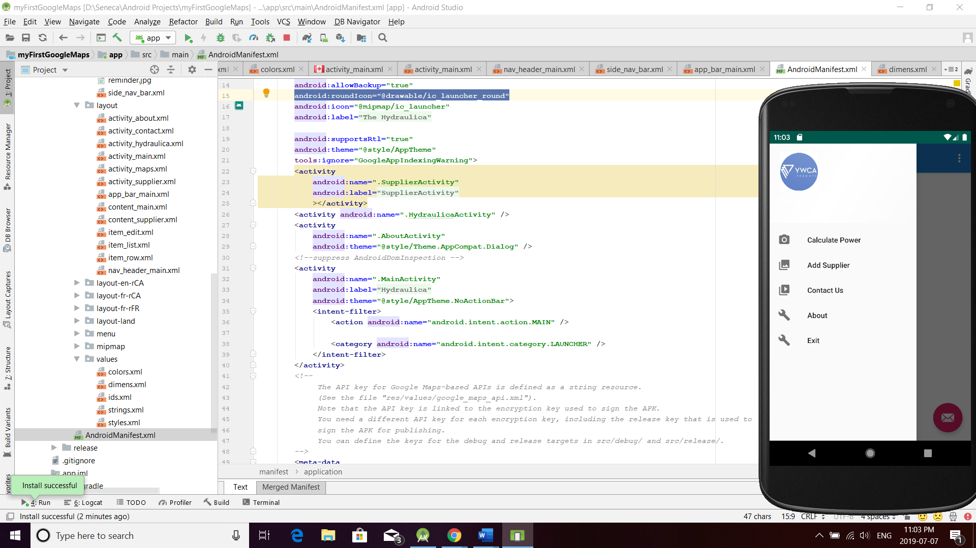

***Calculate Cylinder Force***: An Activity prompting the user to enter 2 variables: (***Pressure in psi***) x (***Cylinder Area in sq. in***).

Before displaying the result of the calculation run a “Frame-by-Frame” animation of a car cylinder.

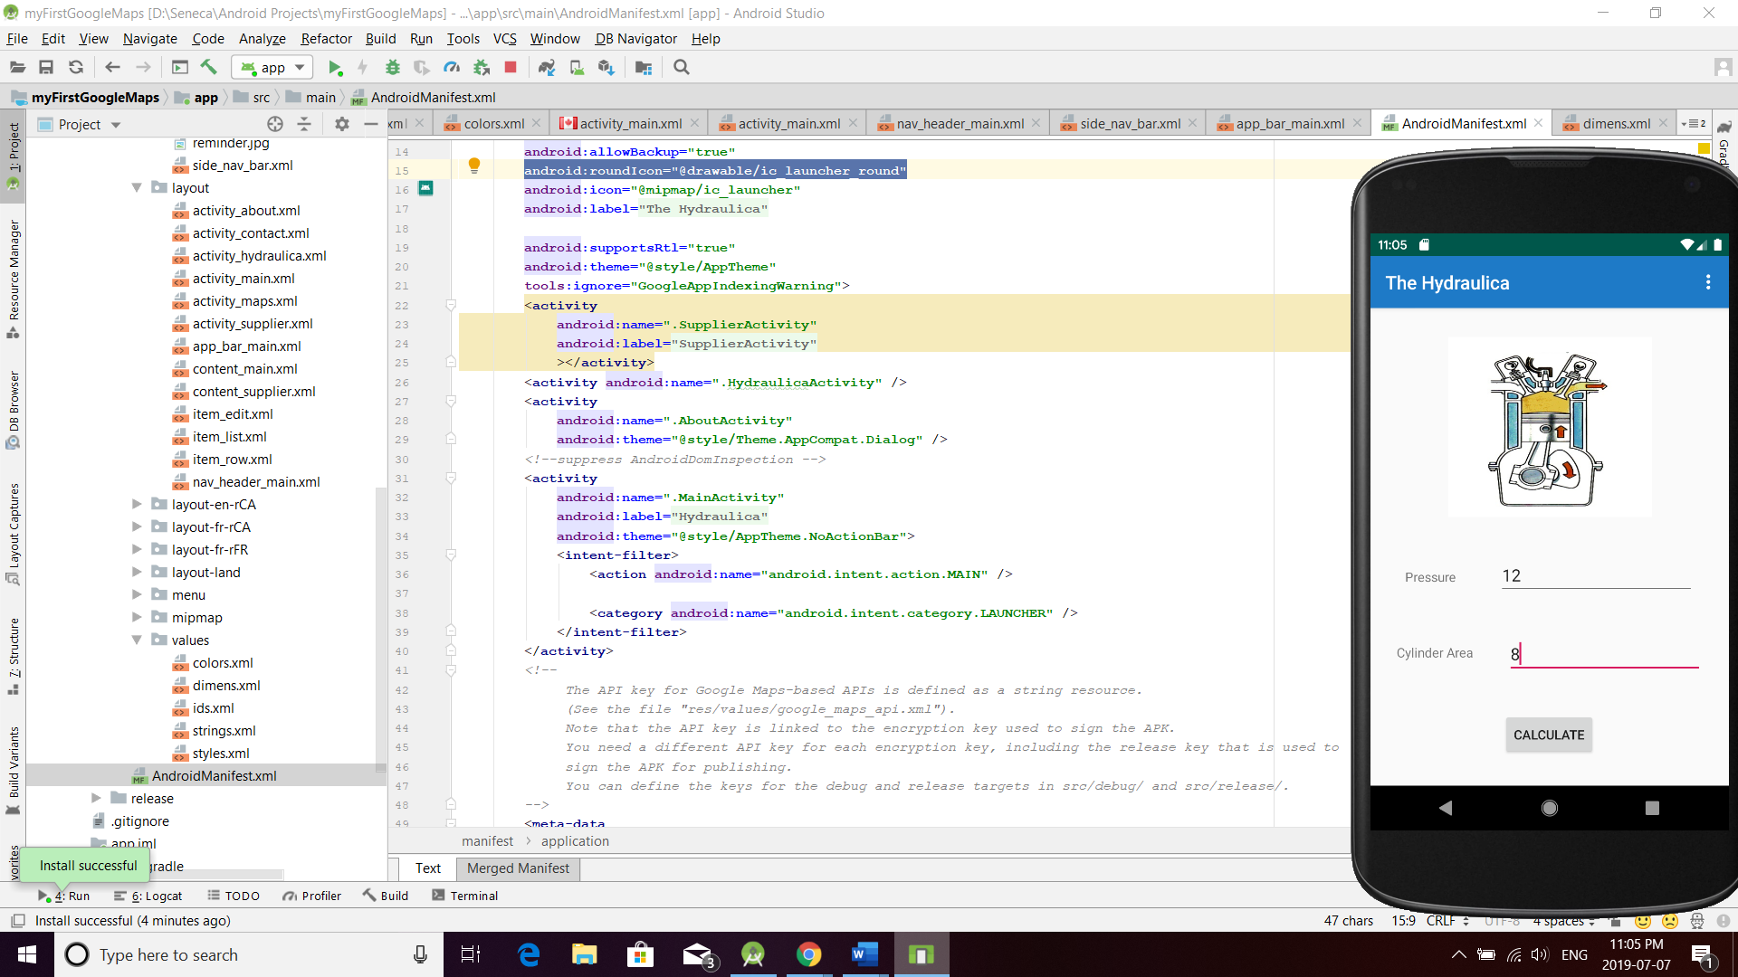

Once the user presses the “CALCULATE” button, an AlertDialogFragment will be shown with the result of the Calculation.

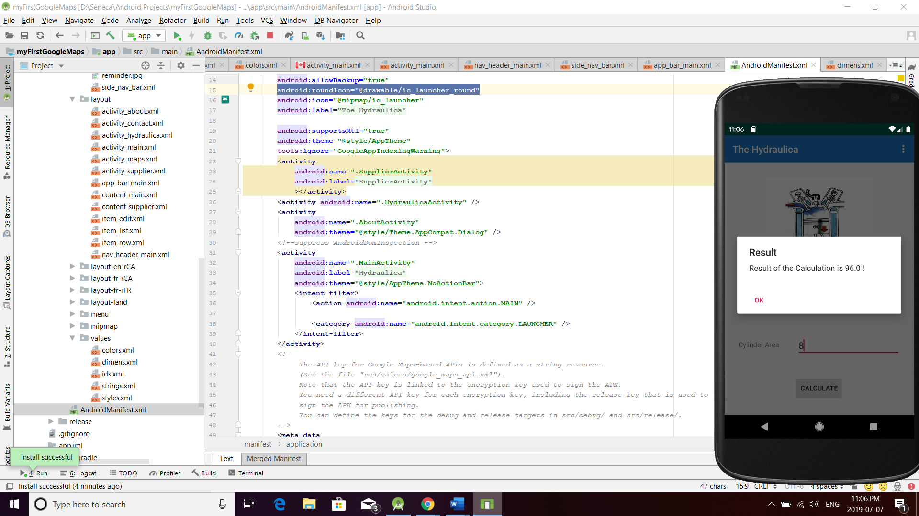

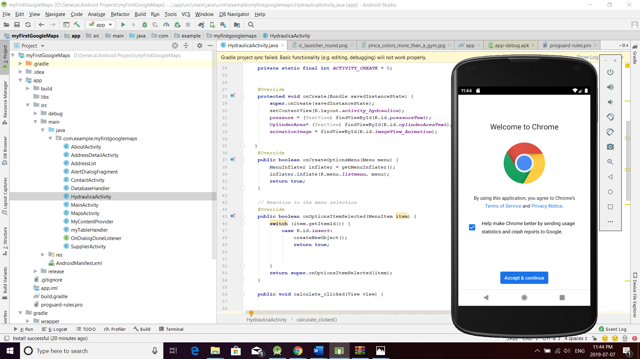

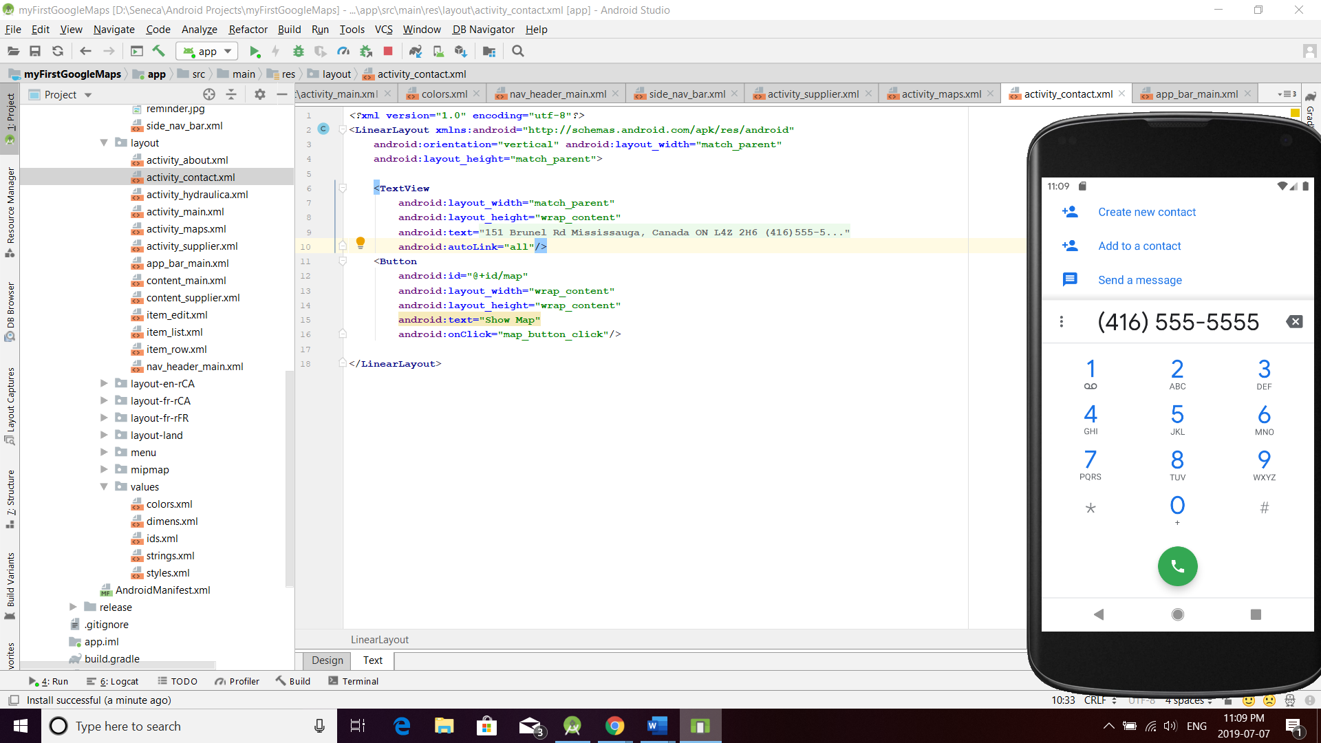

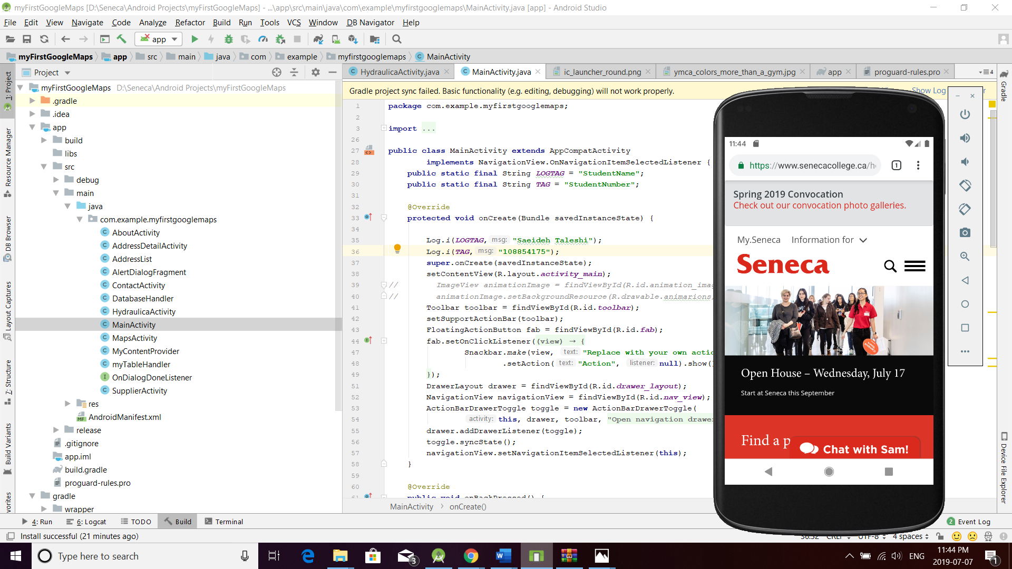

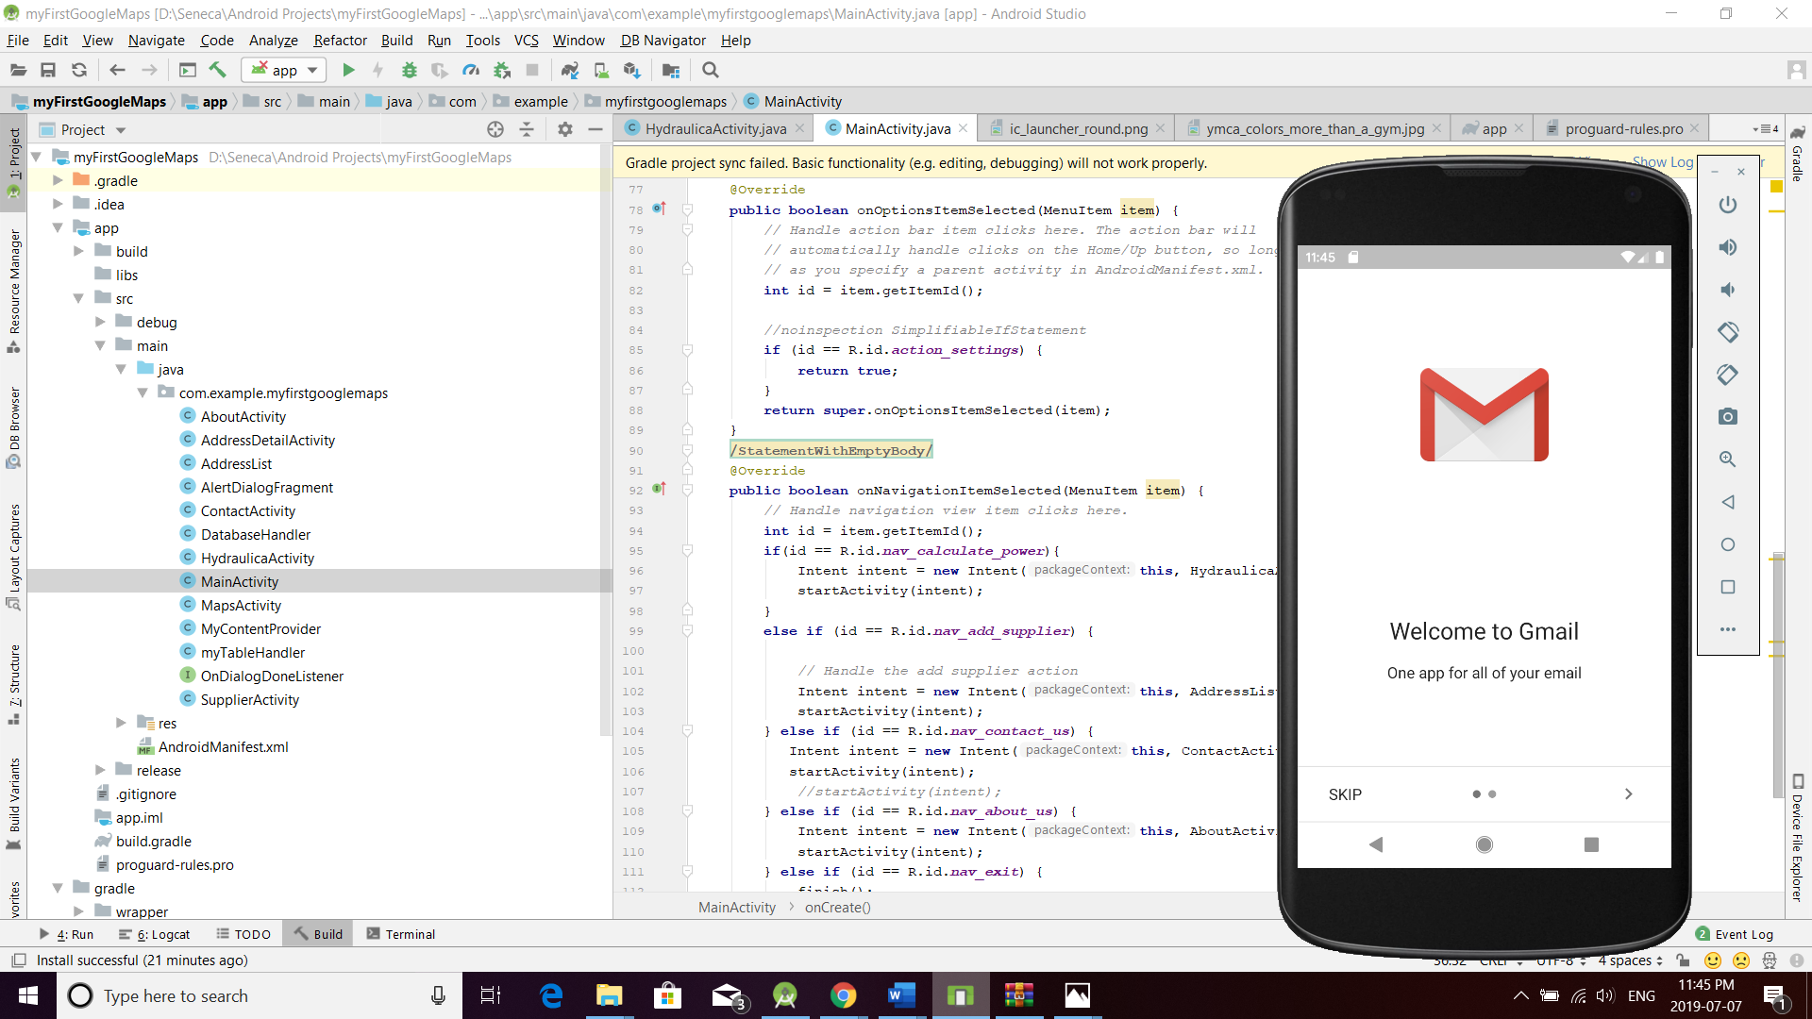

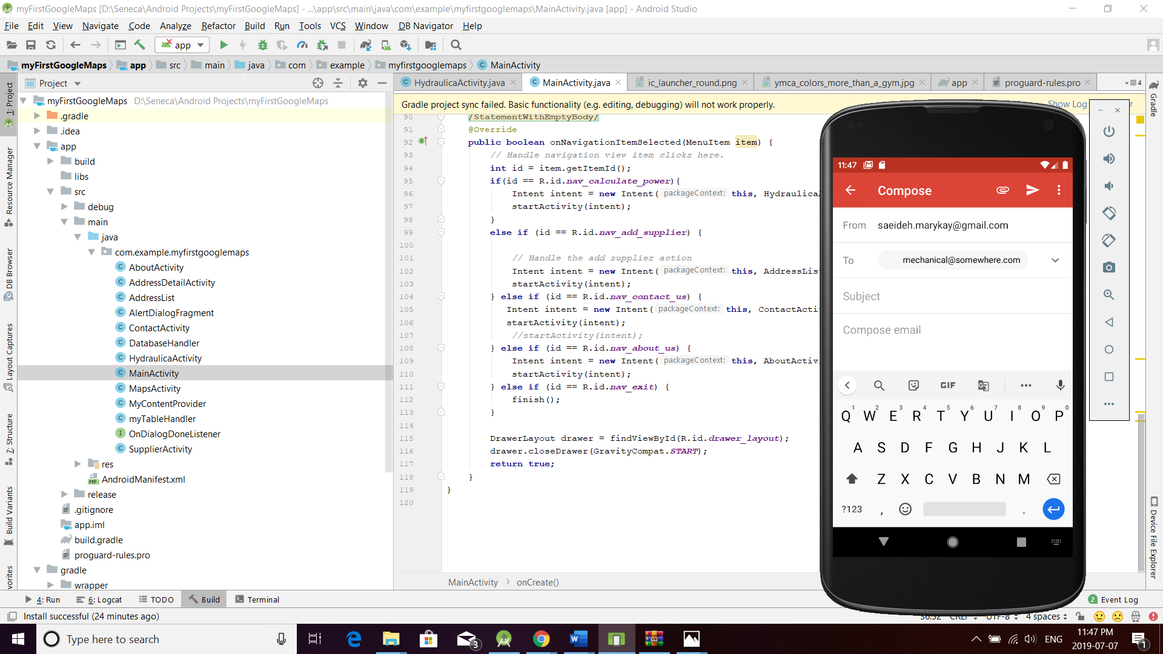

* ***Contact Us Activity***: An Activity or Fragment showing the following contact details:

*Mechanical 2020 Inc.*

*5555 Main St. (suite 101)*

*Toronto, ON*

*M5M 5M5*

*tel.: (416)555-5555*

*email:* [*mechanical@somewhere.com*](mailto:mechanical@somewhere.com)

*url:* [*http://www.senecacollege.ca*](http://www.senecacollege.ca/)

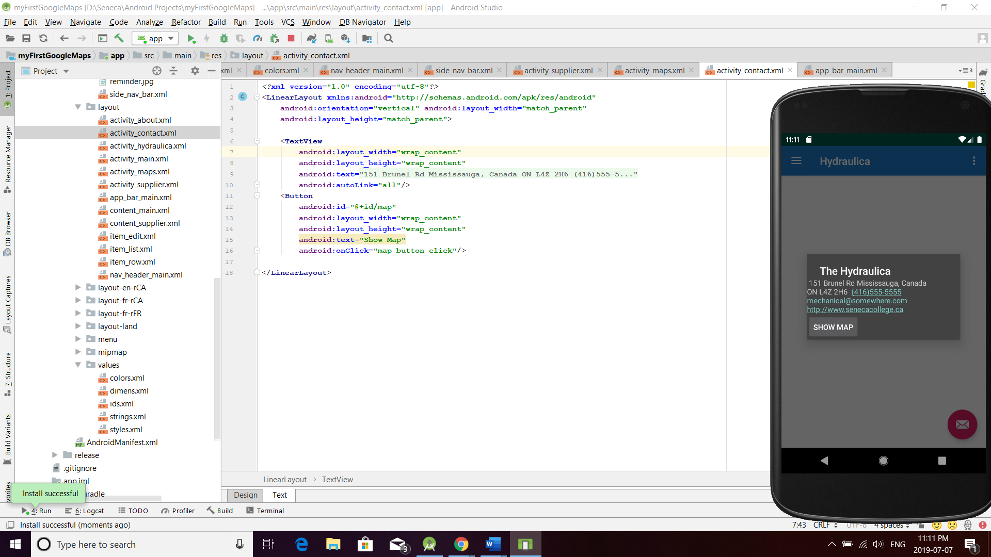

When user clicks on Show Map button, He can see the map on Google Maps.

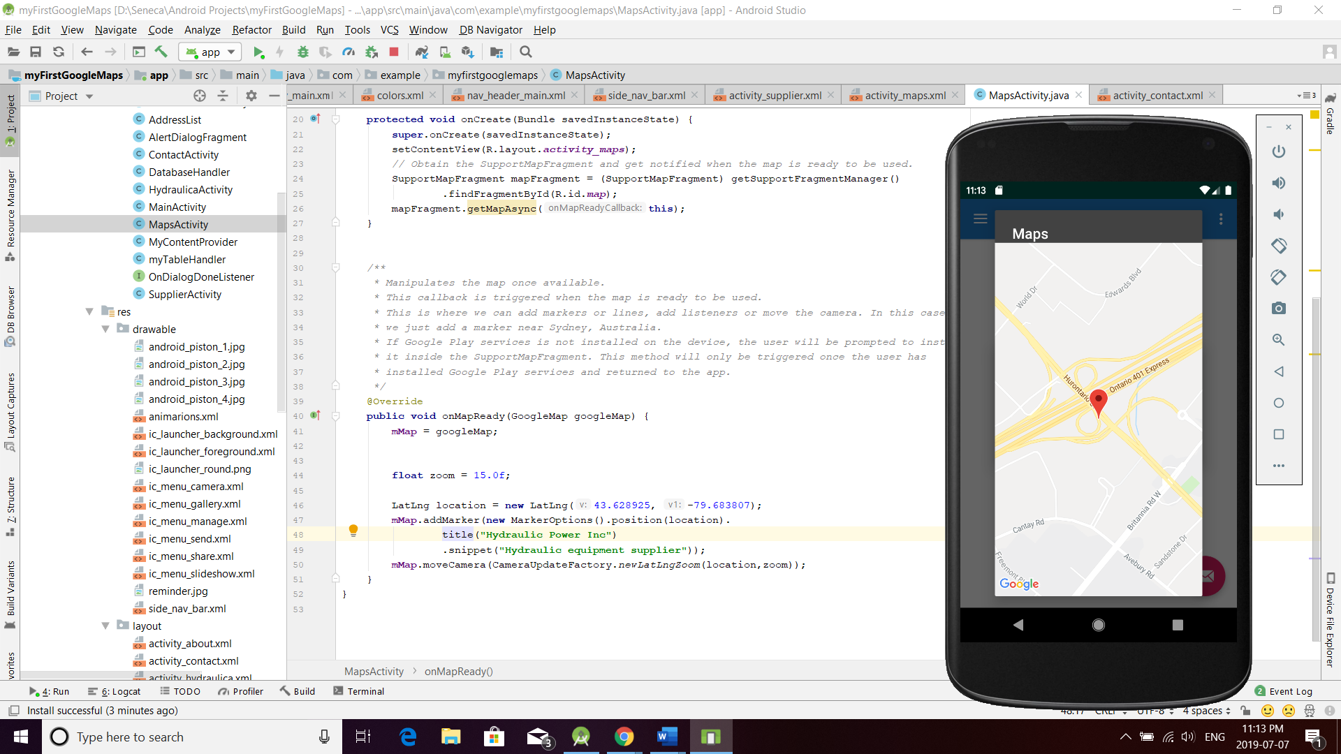

* ***About Activity***: Inplement *Theme.AppCompat.Dialog*.

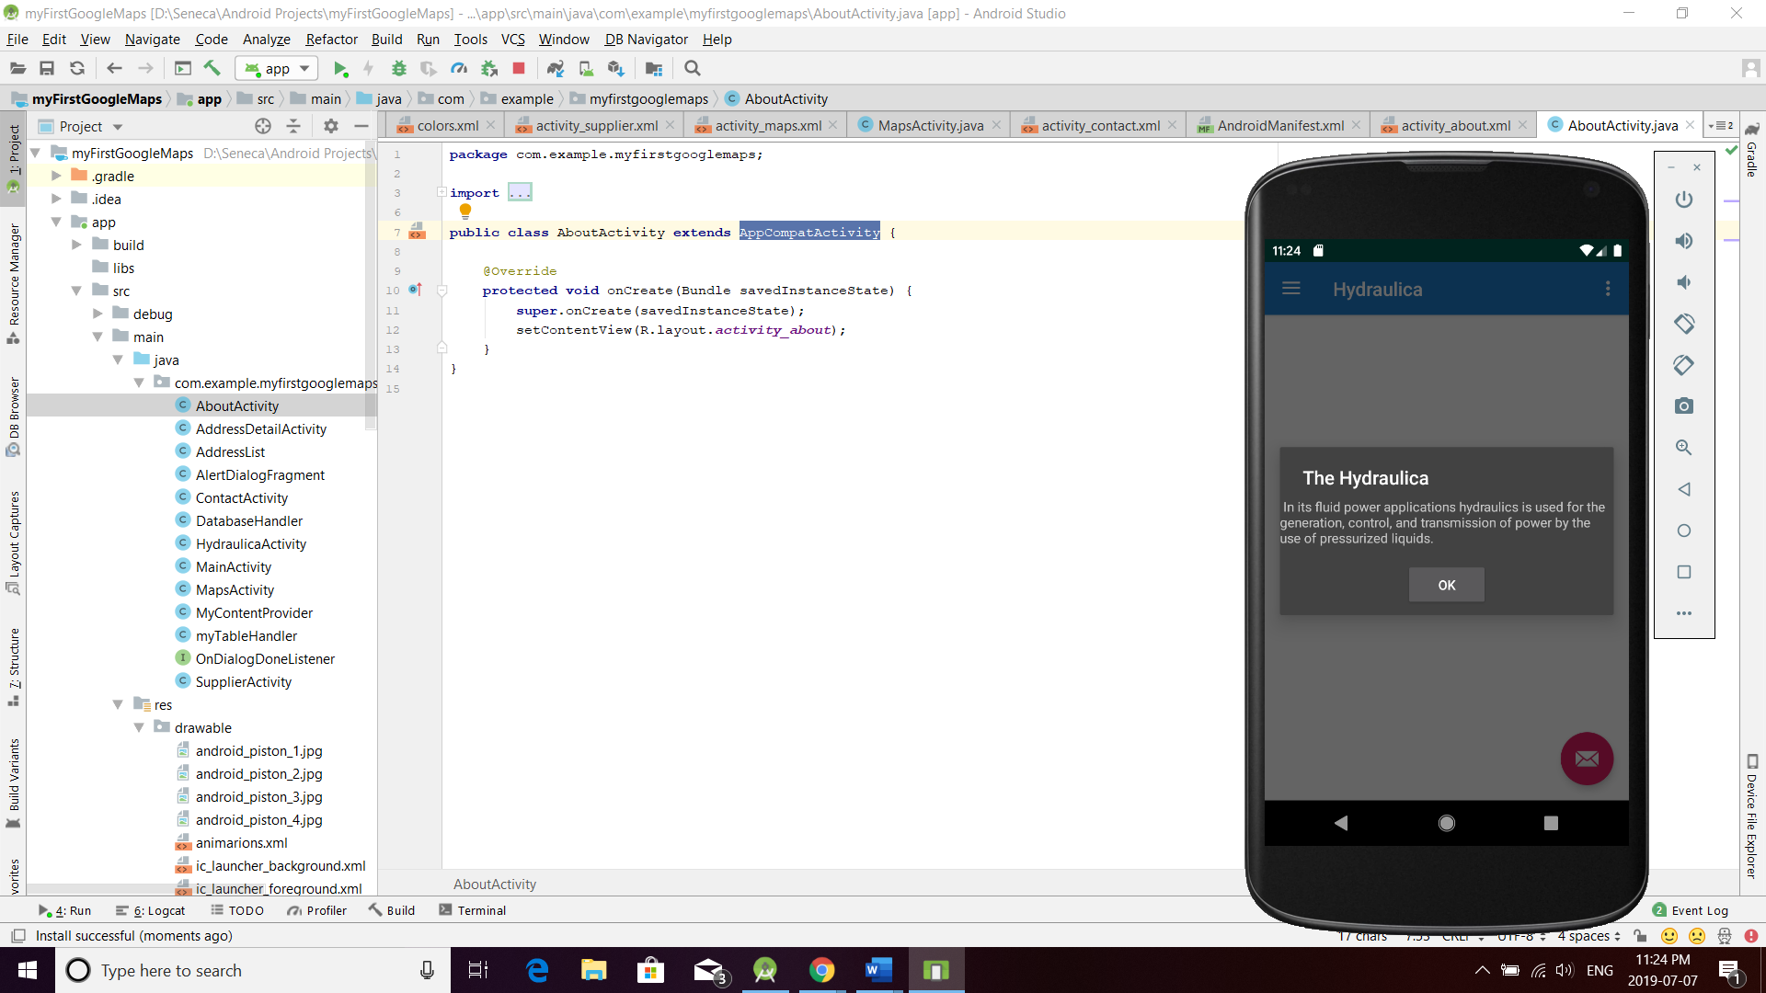

<**activity  
 android:name=".AboutActivity"  
 android:theme="@style/Theme.AppCompat.Dialog"** />

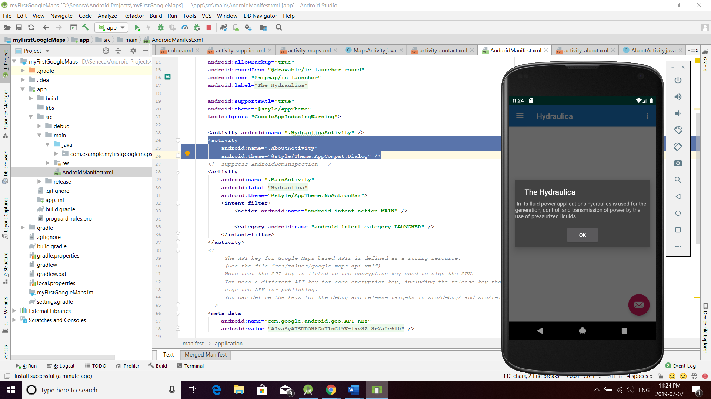

Using a custom JPEG image in the resource drawable or mipmap folder. This will be used by android as your application icon. The file is located on Blackboard – Seneca Resources.

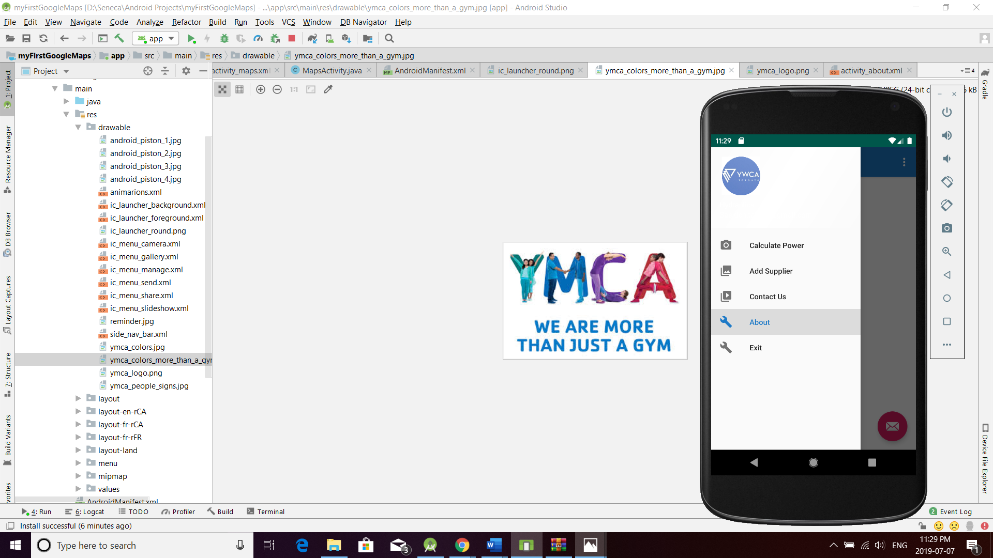

Adding an additional dependency in the project ***build.gradle (MODULE)***.

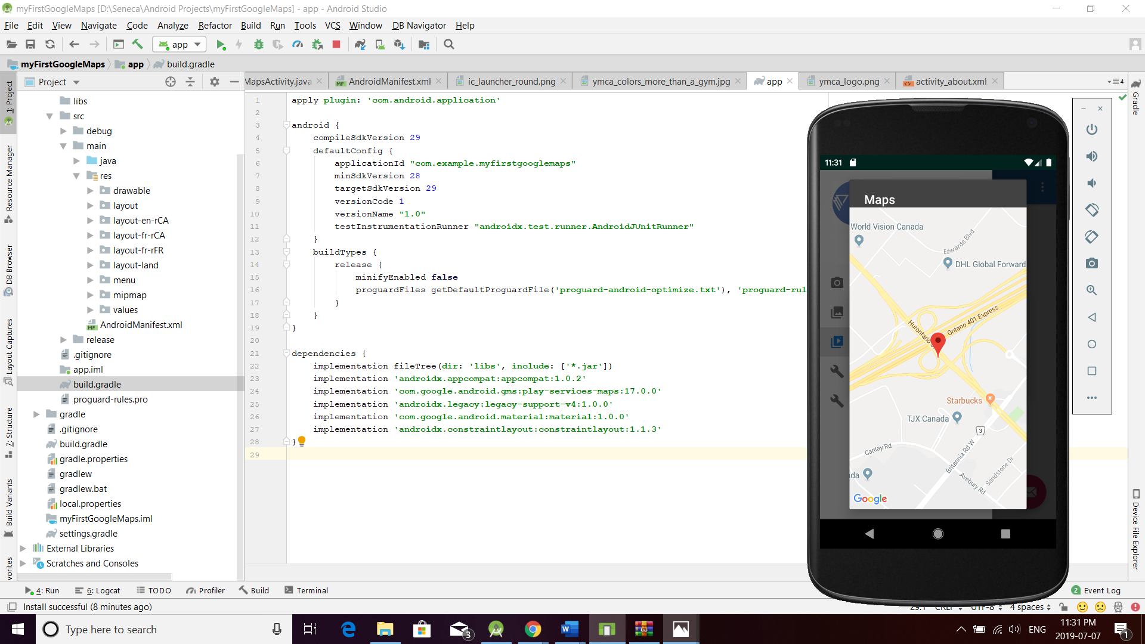

Finished.